British museum
It is a museum in the city of London, United Kingdom. It is one of the most important and visited museums in the world. Its collections cover diverse fields of human knowledge, such as history, archeology, ethnography and art.
The museum was one of the first institutions of its kind in Europe, being the first national museum in the world. It holds over eight million objects from all continents, many of which are stored for studying and restoration, or saved for lack of space to display them. It has the largest reading room in the British Library, a library that although it now has its own headquarters, until 1973 it was also part of the museum, as well as the Natural History Museum of London, which changed its headquarters in 1963 .
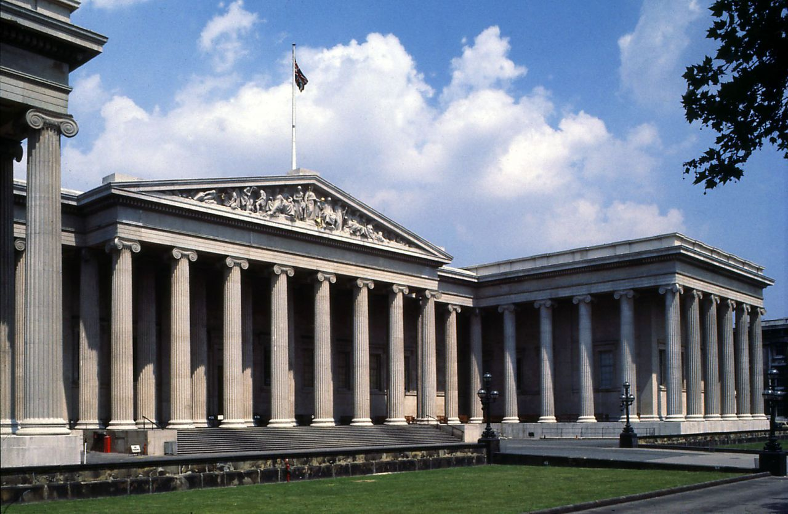
Rubén and Javier.

