APEX LEGENDS
Apex Legends is a free real battle video game developed by Respawn Entertainment and published by Electronic Arts. Set in the same universe as Titanfall, the game was released for Microsoft Windows, PlayStation 4 and Xbox One on February 4, 2019. Apex Legends differs from other Battle Royale games by borrowing the concepts of the shooter hero, with each character of the game, in each player-character Legend shows unique abilities, and mainly requires players to work in squads of three, with the ability to reappear as defeated teammates.
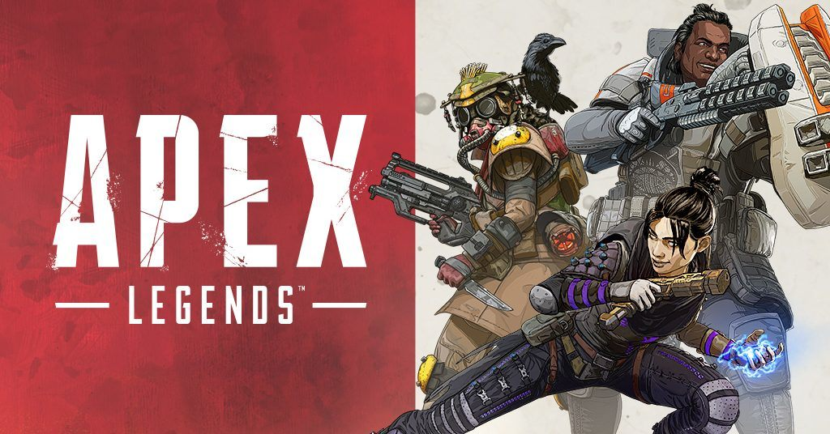

By: Carlos, Adrián and Dani

