BRAWL STARS
Brawl Stars is a real-time action video game developed by Supercell for mobile devices on the iOS and Android platforms. It was released globally on December 12, 2018 and the beta was created on June 15, 2017.
The goal of the game is to get as many trophies as possible, these are achieved in different events that are in the game.
The characters in this game are called brawlers and to get them you need to open boxes.

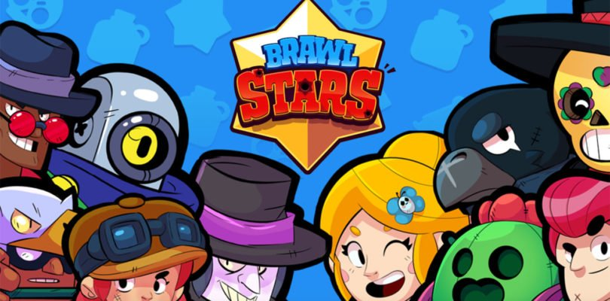

By: Carlos, Adrián and Daniel.

