Rage 2

Rage 2 is a first-person shooter video game developed by Avalanche Studios along with id Software and published by Bethesda Softworks. It's the continuation of the 2010 title, Rage. The game was released for Microsoft Windows, PlayStation 4 and Xbox One on May 14, 2019.

The game is a first person shooter. The players take over the ranger Walker, who is free to explore the post-apocalyptic open world of the game. Players will have access to several firearms to fight against enemies. Players can further maximize the power of these firearms by activating the Overdrive mode, which will also increase the rewards of the game.

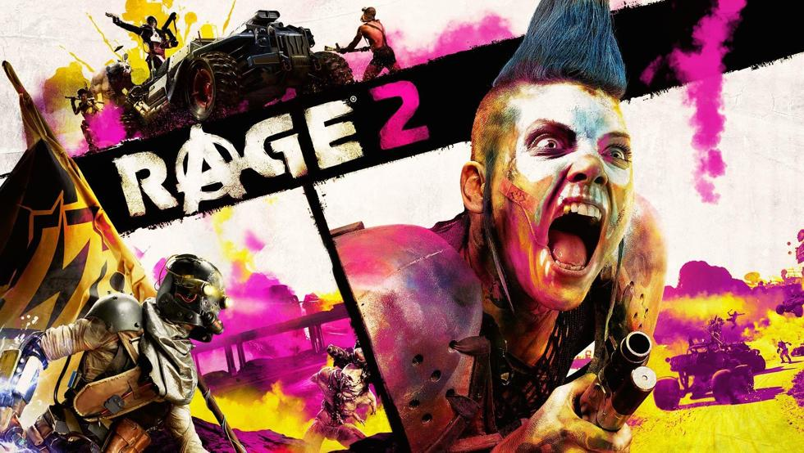

By: Carlos , Daniel, Adrián